KSV Software Milestone 2 (Voting App):

1. Mindmap link: [Voting App Mindmap - miro.com](https://miro.com/app/board/uXjVOVsN3-w=/)

Screenshot:

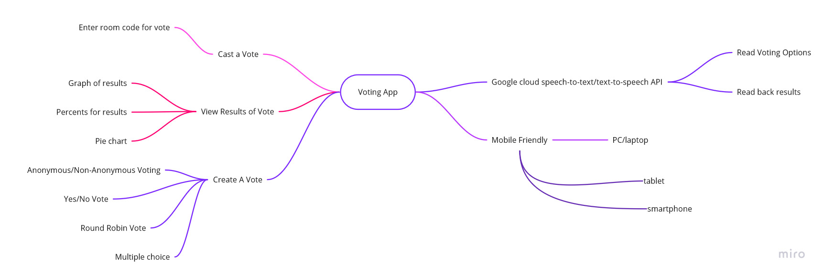

1. Vision statement:

The Voting App is a .net mvc web app that allows groups of people to hold a vote through the app in such a way that the vote cannot be swayed by things like peer/social pressure, and allow the vote to be anonymous. Some benefits of this app are the ability to create a vote in the app for a group and have it be anonymous or non-anonymous, be able to support different types and voting like round robin and multiple choice, and to allow the person that created the vote to see analytics of the vote to see how it was distributed via graphs and percentages. We think that this app would be useful in scenarios where a vote needs to be taken in a group, but there is the possibility of the vote being influenced by an outside party. One competitor to this is Loomio though they don’t support multiple kinds of voting and their product costs money where this app would be free for basic users.

1. **List of needs**  **List of features**

|  |  |
| --- | --- |
| Mobile friendly | Create a vote |
| Keeping personal/voting data secure/private | View results of votes |
| Database to store voting information with network access | User accounts / authentication |
| Accessible through web | View and then cast a vote on a vote that has been created |
|  | View analytics of a vote |
|  | Google cloud ai TTS and STT |
|  | Cast an anonymous vote |
|  | make sure votes are unique |
|  | share vote with others link or code |
|  | Different kinds of votes (ranked voting as an option) |

1. Diagram for initial system/network architecture for this project link (export as SVG):

[Voting App System/Network Architecture - app.diagrams.net](https://app.diagrams.net/#G10xC6OF-ujXiYfj2i9bnM_emStXILRSM8)

Screenshot:

